Domayne’s Intense Wool Sofa

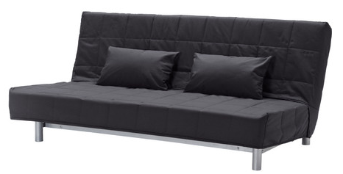

|  |
| --- |
| **DESCRIPTION** |
| Intense wool derived Sofa produced by Domayne’s Sofa, presents a black pitched very comfortable sofa. The extra-long back relaxes the spinal cord extra long legs on bottom provide stability for the sofa. Available in Black bulky form and hand stitched cloth, the Delmard air filled leather with thick form will add comfort and class to the drawing room. |

|  |  |  |
| --- | --- | --- |
| **Price** | **4000$** | |
| **Dimensions** | **H** x **W** x **L** | **35in x 32in x 64in** |
| **Features** | **After a back aching day you can relax and fix your back and enjoy our comfort level.** | |
| **Finished** | **Long Ledged Back** | |
| **Available in** | **Black and Green** | |